




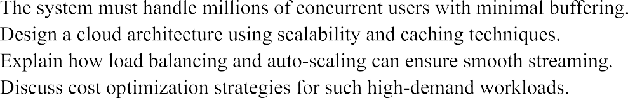
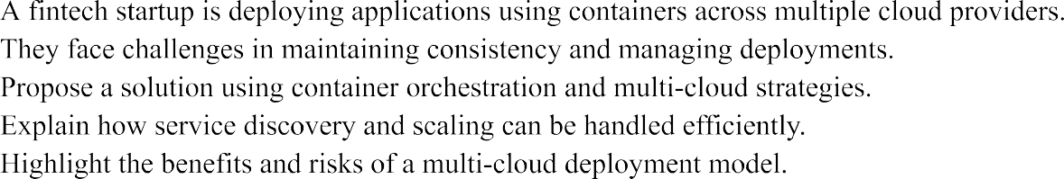

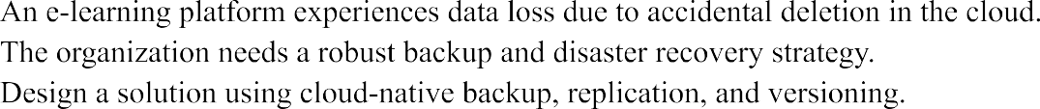

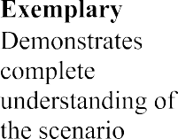
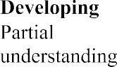
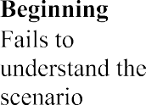
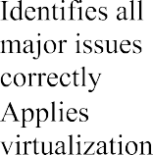
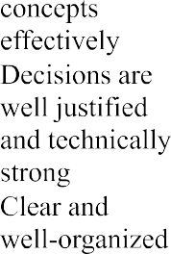
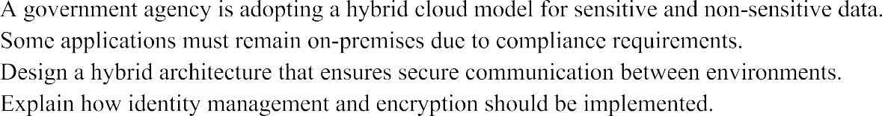
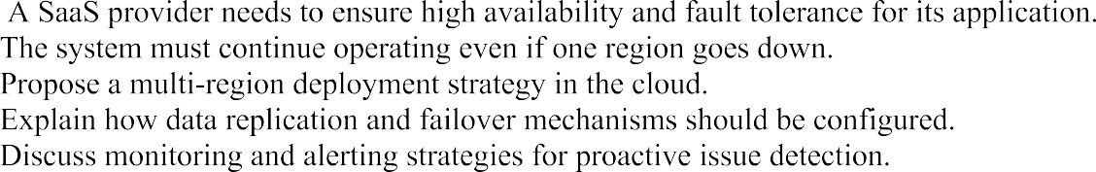

 |  |  | 
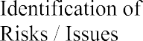 |  |  | 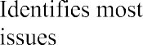 | 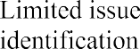 | 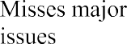
 |  |  | 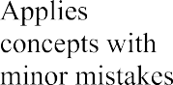 | 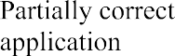 | 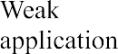
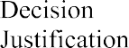 |  |  | 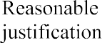 |  | 
 |  |  |  | 

SIMATS ENGINEERING
ASSESSMENT TOOL 2: SCENARIO-BASED — ANSWERS
Course: Cloud Computing and Big Data Analytics | Course Code: CSA15
1. Cloud Architecture for a High-Traffic Video Streaming Platform
a) Scalable architecture and caching
The platform should use a multi-tier cloud architecture. Users connect through a DNS-based global traffic manager and a content delivery network (CDN). The CDN serves frequently watched videos from edge locations close to users, reducing latency and the load on the origin servers. Requests that are not cached are routed through a web application firewall and load balancer to a pool of stateless application servers deployed across multiple availability zones.
Video files should be stored in durable object storage, with separate storage tiers for frequently and rarely accessed content. A transcoding pipeline can create multiple resolutions and bitrates so that adaptive bitrate streaming adjusts video quality to the user’s bandwidth. Metadata can be stored in a managed database, while frequently accessed metadata and session information can be held in a distributed cache. Queues and background workers should process uploads, transcoding, and other tasks asynchronously.
b) Load balancing and auto-scaling
Load balancers distribute incoming requests across healthy instances using health checks and suitable routing policies. If an instance or availability zone fails, traffic is directed to healthy capacity. Auto-scaling adds instances when metrics such as CPU utilization, request rate, active connections, or queue depth exceed defined thresholds, and removes excess instances when demand falls. Scheduled scaling can prepare for known peak events. Minimum capacity, warm-up time, and scaling cooldowns should be configured to prevent delays or rapid oscillation.
c) Cost optimization and risks
Use CDN caching and cache-control policies to reduce origin egress and compute demand. Apply lifecycle rules to move older content to lower-cost storage, use reserved or savings-plan capacity for predictable baseline workloads, and use spot/preemptible instances only for interruption-tolerant jobs such as transcoding. Monitor cost by service and environment, set budgets and alerts, and right-size instances from observed utilization.
Major risks include traffic spikes, regional outages, cache misses, data egress charges, and abuse or denial-of-service attacks. Mitigate these with multi-zone deployment, origin protection, rate limiting, DDoS protection, capacity tests, monitoring, and tested recovery procedures. These choices balance low buffering and high availability against cost.
2. Multi-Cloud Container Deployment for a Fintech Startup
a) Consistent deployment and orchestration
Package each application and its dependencies into versioned, immutable container images. Store approved images in a registry that can be accessed securely by each cloud, and scan images for vulnerabilities before release. Use Kubernetes or a comparable managed container orchestration platform in each provider. Keep manifests and deployment definitions in version control and use Helm, Kustomize, or equivalent templates with provider-specific configuration separated from common application settings.
A CI/CD pipeline should run automated tests, security checks, and image scanning, then promote the same tested image through development, staging, and production. Infrastructure as code should provision networks, clusters, policies, and monitoring consistently. Use progressive or canary releases with automated rollback when health metrics degrade.
b) Service discovery and scaling
Within each cluster, use the platform’s service discovery and internal DNS to locate services. For communication across clouds, use a service mesh, private connectivity, or a controlled API gateway with mutual TLS and explicit routing rules. Avoid assuming that private service names resolve across providers. Configure horizontal pod autoscaling based on CPU, memory, request latency, or queue depth, and cluster autoscaling to add worker nodes when required. Define resource requests and limits, readiness and liveness probes, and disruption budgets.
c) Benefits, risks, and controls
A multi-cloud model can reduce dependence on one provider, support geographic reach, and allow teams to choose suitable services. However, it increases operational complexity, networking and data-transfer costs, inconsistent managed-service behavior, duplicated skills, and the risk of configuration drift. Fintech workloads also require strict access control, audit trails, encryption, secrets management, vulnerability patching, and data-residency controls.
Use a common observability platform for logs, metrics, traces, and alerts; standardize policy-as-code and identity federation; and define a clear recovery and failover strategy. Replicate only the data required for the workload, protect it in transit and at rest, and test failover regularly. Multi-cloud is justified when resilience or regulatory needs outweigh its additional cost and complexity.
3. Cloud Backup and Disaster Recovery for an E-Learning Platform
a) Backup, replication, and versioning design
Classify data by importance, including course content, user records, assessments, and configuration. Enable object versioning for uploaded learning materials and use database-native backups with point-in-time recovery for transactional records. Take regular snapshots of persistent volumes and maintain encrypted backups in a separate account or project and, where appropriate, a separate region. Apply retention policies and immutable or write-once backup protection to reduce the risk of accidental deletion or ransomware.
Replication provides a copy in another location but is not a replacement for independent backups: deletions or corruption can also replicate. Use cross-region replication for critical objects and database replicas or log shipping where the recovery requirements justify the cost. Restrict backup deletion permissions and keep backup credentials separate from normal application credentials.
b) RTO and RPO
Recovery Time Objective (RTO) is the maximum acceptable time to restore the service after an outage. Recovery Point Objective (RPO) is the maximum acceptable amount of data loss measured in time. For example, a critical assessment database might require a low RPO through frequent log backups or near-real-time replication, while less critical archived course files may tolerate a larger RPO. The actual targets must be agreed with stakeholders based on business impact and budget.
To meet RTO, maintain documented recovery runbooks, pre-provision or automate replacement infrastructure, keep infrastructure definitions under version control, and periodically restore backups into an isolated environment. To meet RPO, schedule backups and verify their completion, monitor replication lag, and alert on failed jobs. A backup is considered reliable only after restoration has been tested.
c) Business continuity steps
• Identify critical services, dependencies, owners, acceptable downtime, RTO, and RPO.
• Detect the incident, assess its scope, and declare disaster recovery when thresholds are met.
• Isolate compromised or failing resources and preserve logs for investigation.
• Restore identity, network, databases, and application services in the documented dependency order.
• Validate data integrity, access controls, and application behavior before directing users to the recovered environment.
• Communicate service status to learners and staff, then reconcile any data created during recovery.
• Run post-incident reviews and test recovery plans through scheduled exercises.
4. Secure Hybrid Cloud for a Government Agency
a) Architecture and secure connectivity
Place sensitive or regulated applications and data in the approved on-premises environment or private cloud, while using the public cloud for suitable non-sensitive workloads. Connect the environments through redundant site-to-site VPN tunnels or dedicated private links. Segment networks by workload and sensitivity, restrict routes and ports, and use firewalls and security groups to allow only required traffic. Use a controlled API gateway or integration layer rather than exposing internal systems directly.
Apply a consistent identity and access management model with federation, multi-factor authentication, least privilege, and role-based access. Use a centralized identity provider where permitted, but maintain secure break-glass access for outages. Keep administrative access on hardened management paths and log privileged actions.
b) Identity, encryption, and compliance
Encrypt data in transit using current TLS configurations and encrypt stored data using managed or agency-controlled keys according to policy. Protect keys in a key management service or hardware security module, separate key administration from data administration, rotate keys, and audit their use. Classify data and apply controls for residency, retention, data sharing, and deletion. Use configuration baselines, vulnerability scanning, patch management, endpoint protection, and continuous compliance checks.
Centralize security logs and audit trails in a protected system with restricted deletion rights. Monitor identity events, unusual data transfers, configuration changes, and failed access attempts. Establish incident response procedures that identify the responsible team across both environments and meet applicable government regulations and procurement requirements.
c) Hybrid-cloud challenges and mitigations
Common challenges include inconsistent policies, complex networking, latency between environments, duplicated tools, skills gaps, and unclear responsibility boundaries. Reduce these risks through standardized infrastructure as code, policy-as-code, a shared inventory and observability system, documented ownership, regular access reviews, and tested network failover. Keep sensitive information out of public-cloud services unless the agency has approved the service and data handling. The design should be driven by data classification and compliance requirements, not by a blanket assumption that one environment is always safer.
5. High Availability and Fault Tolerance for a SaaS Provider
a) Multi-region deployment strategy
Deploy application instances across multiple availability zones and use a global traffic manager to route users to healthy regions. For a critical SaaS service, choose either an active-active design, where multiple regions serve traffic, or an active-passive design, where a secondary region is ready to take over. Active-active can reduce failover time but requires careful data consistency and conflict handling. Active-passive is often simpler but may need more time to activate and may leave standby capacity underused.
Store stateless application services in scalable compute pools and externalize session state. Replicate databases using a method suited to the consistency requirements; define how writes are handled during a partition and prevent split-brain operation. Keep infrastructure definitions, container images, secrets-recovery procedures, and configuration available to the recovery region. Use health checks and automated failover only with safeguards to avoid routing traffic to a region that is technically reachable but unable to serve requests correctly.
b) Data replication and failover
Use synchronous replication only where the latency and availability trade-offs are acceptable; asynchronous replication can improve performance across distant regions but may lose recent writes during a failure. Monitor replication lag and document the resulting RPO. Use durable backups in addition to replicas, because logical errors and malicious deletions can propagate. Failover runbooks should specify decision authority, traffic switching, database promotion, dependency checks, and rollback or failback steps. Test regional failure scenarios and verify data consistency after recovery.
c) Monitoring, alerting, and proactive detection
Collect service-level indicators such as availability, request latency, error rate, throughput, queue depth, database health, and replication lag. Define service-level objectives and alert on user-impacting symptoms as well as infrastructure metrics. Use centralized logs, distributed tracing, synthetic transactions, and real-user monitoring to identify failures across service boundaries. Alerts should have clear severity levels, ownership, and actionable runbooks; reduce alert fatigue by grouping correlated events.
Run load tests, chaos or fault-injection exercises, backup restoration tests, and disaster-recovery drills. Use rate limiting, circuit breakers, bounded retries with backoff, bulkheads, and graceful degradation to prevent one failing dependency from cascading across the service. Review incidents and capacity trends regularly. These practices improve fault tolerance and make recovery measurable rather than assumed.
Rubric alignment
These answers address scenario understanding, identification of risks and issues, application of cloud concepts, justified design decisions, and clear organization. In an evaluated submission, the final architecture and recovery targets should be adjusted to any specific service limits, regulatory rules, budget, and business requirements stated by the organization.

